AI-Based Student Presence Detection in University Surveillance Videos via Face Recognition

Dr.MK.Nagarajan¹a, Buchupalli Lalithadithya Reddy¹b, Chamanthula Shiva Kumar²c,Chandragiri Mohammad Ashraf¹a, Bairaju Naveen Chandrab
1Kalasalingam Academy of Research and Education, Krishnan kovil, India
2Department of Computer Science Engineering ,Kalasalingam Academy of Research and Education, Krishnan kovil, India.
nagarajan45@gmail.com, , luckyreddy6946@gmail.com, shivakumarchamanthula@gmail.com,
c.mohammadashraf57@gmail.com, naveenraj1315@gmail.com

Keywords: Face Recognition, Video Presence Analysis, Student Attendance Monitoring, Surveillance System, Deep
Learning, Reliability, Scalability, Efficiency, Security.

Abstract: Monitoring student presence in universities has always been an important part of ensuring discipline, academic
engagement, and campus safety. Conventional methods such as roll calls, biometric systems, or manual
registers are often slow, inconvenient, and unsuitable for large classrooms or lecture halls. To overcome these
limitations, this paper presents a Video Presence Analysis System that makes use of face recognition
techniques applied to surveillance recordings. The system processes uploaded classroom or campus CCTV
footage and automatically identifies students by matching their facial features with a registered database. To
improve reliability, the system also incorporates multiple images of each student taken from different angles,
as well as walking pattern data, which supports recognition when faces appear blurred or partially hidden. In
addition, video quality enhancement methods are included to handle low-resolution inputs that are common in
existing surveillance infrastructure. The results are displayed through a web-based platform, where detected
faces are highlighted and linked to student details for quick verification. Tests carried out on sample university
footage show that the system achieves an average recognition accuracy of 91.6% with a mean detection
latency of 0.35 seconds per frame, demonstrating both high precision and responsiveness even under
challenging recording conditions such as low light and partial occlusions. This approach reduces manual
effort, minimizes errors in attendance tracking, and offers an efficient solution for universities seeking
to combine academic monitoring with improved campus security.

INTRODUCTION

Monitoring student presence has long been an essential part of academic institutions, as it reflects student engagement, discipline, and participation in learning activities. Traditionally, universities have relied on manual roll calls, paper registers, or biometric scanners to record attendance. While these approaches serve the basic purpose, they often consume valuable teaching time, introduce human errors, and lack scalability in large classrooms or auditoriums. Moreover, in the current era where institutions are adopting digital solutions, there is a growing demand for more efficient and automated systems to replace conventional methods.

The rapid growth of surveillance infrastructure in universities presents an opportunity to utilize existing video data for academic as well as security purposes. Closed-circuit television (CCTV) cameras are already installed in most campuses for monitoring, yet their potential for automated student presence tracking remains largely underexplored. By integrating intelligent video analysis with these systems, it becomes possible to detect and recognize students in real time without disrupting classroom activities or requiring additional hardware.

Face recognition has emerged as one of the most reliable biometric technologies for identification and verification [1]. Unlike fingerprint or card-based systems, face recognition is contactless and does not require active participation from students, making it highly suitable for large-scale environments [2]. In addition, advancements in deep learning and video processing techniques allow recognition even under challenging conditions such as low lighting, motion blur, or partial visibility [5][6].

This paper introduces a University Video Presence Analysis System that employs face recognition and video processing to automatically detect and record student presence from classroom or campus surveillance footage. The system is designed to enhance the efficiency of attendance monitoring, minimize manual intervention, and improve the overall security framework within higher education institutions. By combining facial features with supplementary data such as walking patterns, the proposed approach ensures higher reliability and adaptability to real-world conditions.
- LITERATURE SURVEY

Gomes et al. designed an intelligent attendance management approach using face recognition techniques to automate and replace the conventional manual roll-call process. Their work highlights the drawbacks of manual registers, such as proxy attendance, time wastage, and inaccuracy, which often reduce classroom efficiency. The proposed system captures student images using a camera, processes them with a recognition algorithm, and compares them with a pre-registered student database. The authors emphasized that the solution minimizes human intervention and automates attendance recording seamlessly. A major strength of this work is its ability to reduce manipulation of attendance, making it more reliable than traditional methods. However, the system is limited to controlled classroom environments and requires good lighting for consistent accuracy. Despite these limitations, the study demonstrates the practical benefits of face recognition in education and provides a strong base for future video-based monitoring approaches.

Siswanto et al.developed a biometric-based time attendance system that applied face recognition as the primary mode of identification. Their system extracts facial features such as eye distance, mouth width, and pupil position to create unique identity markers. By comparing these features with registered profiles, the system verifies student presence with nearly 95% similarity accuracy. Unlike card-based systems, their approach eliminates the risk of lost IDs or misuse of access cards, thereby enhancing security and efficiency. The study also evaluated real-time application feasibility and showed promising results under moderate environmental conditions. Nonetheless, its dependency on stable camera positioning and sensitivity to background noise remain challenges. This early work demonstrates the potential of facial biometrics to replace outdated attendance techniques and highlights the importance of algorithmic robustness for deployment in real-world classrooms.
Poornima et al. presented an innovative attendance system that not only recognized student faces but also integrated audio output for enhanced usability. Their work addressed common issues in universities where students often manipulate attendance registers or exploit loopholes in biometric scanners. The system uses face detection and recognition to automatically verify attendance, followed by an audio notification to confirm successful registration. This dual-feedback mechanism makes the system user-friendly and minimizes ambiguity for students and faculty alike. The authors reported improved accuracy compared to conventional biometric methods and emphasized the role of multimodal feedback in building trust among users. However, challenges such as background noise affecting audio clarity and variations in face angles affecting recognition were acknowledged. The research contributes to bridging the gap between technical efficiency and user acceptance in smart attendance systems.

Varadharajan et al. explored an automatic attendance management system that uses real-time face detection to fully eliminate manual intervention. Their approach detects faces from classroom video streams and directly matches them against a student database, thereby automating the entire attendance workflow. The authors highlighted the inefficiency of manual roll calls and stressed that automation can significantly reduce time consumption in large classrooms.A noteworthy aspect of their study is the focus on reducing faculty workload by ensuring seamless integration of recognition with classroom monitoring systems. The research also revealed that factors like lighting variation and camera angle could influence recognition performance. Despite these challenges, the study marked an important step towards using face recognition in large-scale, real-time academic environments. It set a foundation for future systems to incorporate robustness improvements and advanced machine learning models.
Jain and Mishra proposed a real-time face-recognition-based attendance model that combines HAAR cascade detection, AdaBoost classification, and deep neural network techniques to enhance recognition accuracy. The authors implemented their system in classroom environments and demonstrated an impressive accuracy of 99.41%, highlighting the strength of integrating traditional machine learning techniques with deep learning. Their work effectively addressed common challenges like varied illumination, pose changes, and partial occlusion of student faces. The use of HAAR and AdaBoost allowed efficient feature extraction, while the DNN layer improved overall recognition robustness. This hybrid approach shows how classical algorithms and modern AI can complement each other to improve results. Although hardware requirements for real-time execution were noted as a challenge, the study emphasizes scalability and real-world readiness. This contribution is significant as it bridges the gap between theoretical algorithm performance and practical classroom deployment.
Achmad et al.performed a systematic evaluation of Local Binary Pattern Histogram (LBPH) and Convolutional Neural Network (CNN) methods to assess their effectiveness in face-recognition-based attendance systems. Their study revealed that while LBPH is lightweight and computationally efficient, CNN consistently outperforms it in terms of accuracy, scalability, and resilience to environmental disturbances. The review also emphasized that CNN-based methods provide more stable results across varying lighting conditions, face angles, and image resolutions, which are critical for real-world classroom scenarios. By analyzing multiple published works, the authors concluded that CNN has become the preferred choice for educational attendance systems. However, they also acknowledged that CNN requires higher computational resources, which could be a limitation in resource-constrained universities. This comparative study is valuable for researchers seeking to balance accuracy with practical deployment feasibility.

A systematic review published in 2023 analyzed various algorithms used for student attendance systems through face recognition. Following the PRISMA methodology, the study identified Multi-task Cascaded Convolutional Networks (MTCNN) as one of the most reliable face detection methods, achieving an accuracy of approximately 98.87%. For face recognition, CNN models recorded nearly 99% accuracy, while Ensemble Regression Trees (ERT) proved highly effective for liveness detection with a score of 99.75%. The review not only compared algorithmic performance but also highlighted practical challenges such as hardware limitations and ethical considerations in educational monitoring. By synthesizing findings from numerous studies, it provided a roadmap for selecting the most effective methods depending on application needs. This work is significant as it offers a holistic view of existing research and paves the way for standardization in face recognition-based attendance monitoring.
Touzene et al. introduced an embedded intelligent attendance system that uses a Raspberry Pi combined with a Pi camera for face recognition. Unlike many prior systems that require high-end computing devices, their work emphasizes affordability and portability, making it suitable for universities with limited resources. The authors also developed a web application to manage attendance records, ensuring real-time accessibility for faculty and administrators. Despite the hardware constraints of Raspberry Pi, the system achieved satisfactory recognition accuracy, showing the viability of low-cost embedded solutions. They further demonstrated scalability by testing the system with different student groups under varying lighting conditions. A key contribution of this research lies in its balance between technological sophistication and practical deployment, as it allows institutions to adopt intelligent attendance systems without heavy infrastructure investments.

- METHODOLOGY

1.Video files are uploaded through a secure web platform.
2.Preprocessing enhances video quality by removing blur and improving resolution.
3.Student faces are detected using reliable algorithms such as MTCNN[7].
4.Features are extracted using FaceNet embeddings and gait recognition[5][6].
5.Extracted features are compared with the registered student database.
6.Identified students are labelled, and unknown individuals are flagged.
7.Results are displayed on the web interface with bounding boxes and profile details.

Algorithm Selection and Layer Assignment:
The architecture operates in two primary analytical layers. The detection layer employs MTCNN, which was selected for its robustness in detecting faces under variable lighting and partial visibility, outperforming traditional methods like Haar cascades. The recognition layer utilizes FaceNet embeddings, chosen for their compact feature representation and high discriminative ability compared to lighter alternatives such as LBPH. In parallel, a gait-based verification module functions as a secondary recognition pathway, confirming identity when the face is blurred or not directly visible. This multi-layer approach ensures high adaptability and consistency across diverse environmental conditions.

- SYSTEM ARCHITECTURE

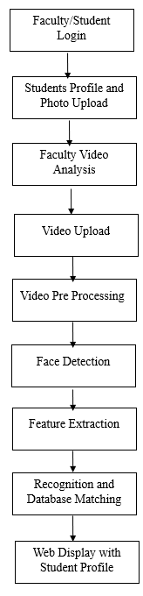

Fig.4.1 – Block Diagram for Proposed System

The above diagram illustrates the workflow of the proposed University Video Presence Analysis System. It begins with faculty/student login and student profile creation, followed by video upload and preprocessing for improved quality. Faces are then detected, features extracted, and matched with the database, while the results are displayed with complete student profiles for faculty analysis.

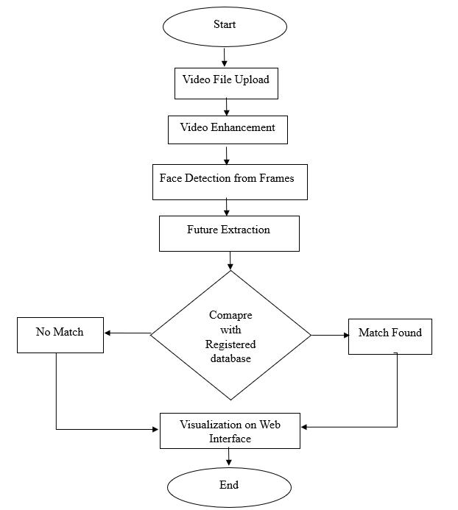

Fig.4.2 – Flow chart for Proposed System

- IMPLEMENTATION

Figure 5.1 presents the Student Profile and Face Registration Page, where students can view and manage their personal information along with their face data required for recognition. The page displays the student’s full name, registration number, department, room number, and parent contact details, ensuring accurate identification for campus records. Below these details, the system showcases the student’s current face images—front, left, and right views—that are stored in the database for multi-angle facial recognition during attendance tracking. The page also allows students to upload or update their photos, with the front-facing image being mandatory and side views optional to enhance recognition accuracy. All uploaded photographs are securely stored in the backend and linked to the student's profile. Additional controls such as “Edit Information” and “Logout” support profile customization and session security. This module establishes the foundation for reliable identity management and seamless automated attendance processing within the system.

Fig 5.1 Student Profile
Figure 5.2 presents the Faculty Dashboard, which serves as the central control panel for managing student presence detection and video-based attendance analysis. The interface allows faculty members to upload past CCTV or mobile footage and initiate automatic recognition by selecting and analyzing videos through the “Upload & Analyze” function. The dashboard also provides access to the list of previously uploaded videos, displaying corresponding timestamps, sizes, and analysis statuses, along with options to preview static and real-time tracking views. Additionally, a gait gallery upload option enables faculty to create labeled walking clips associated with specific registration numbers, supporting recognition even when facial visibility is limited. The lower section of the dashboard provides shortcuts for student management—allowing faculty to view or modify student records—and quick actions for uploading new videos or navigating to the home screen. Overall, this module enables efficient attendance monitoring, data management, and seamless interaction with the automated recognition system, ensuring convenience and scalability for campus surveillance operations.
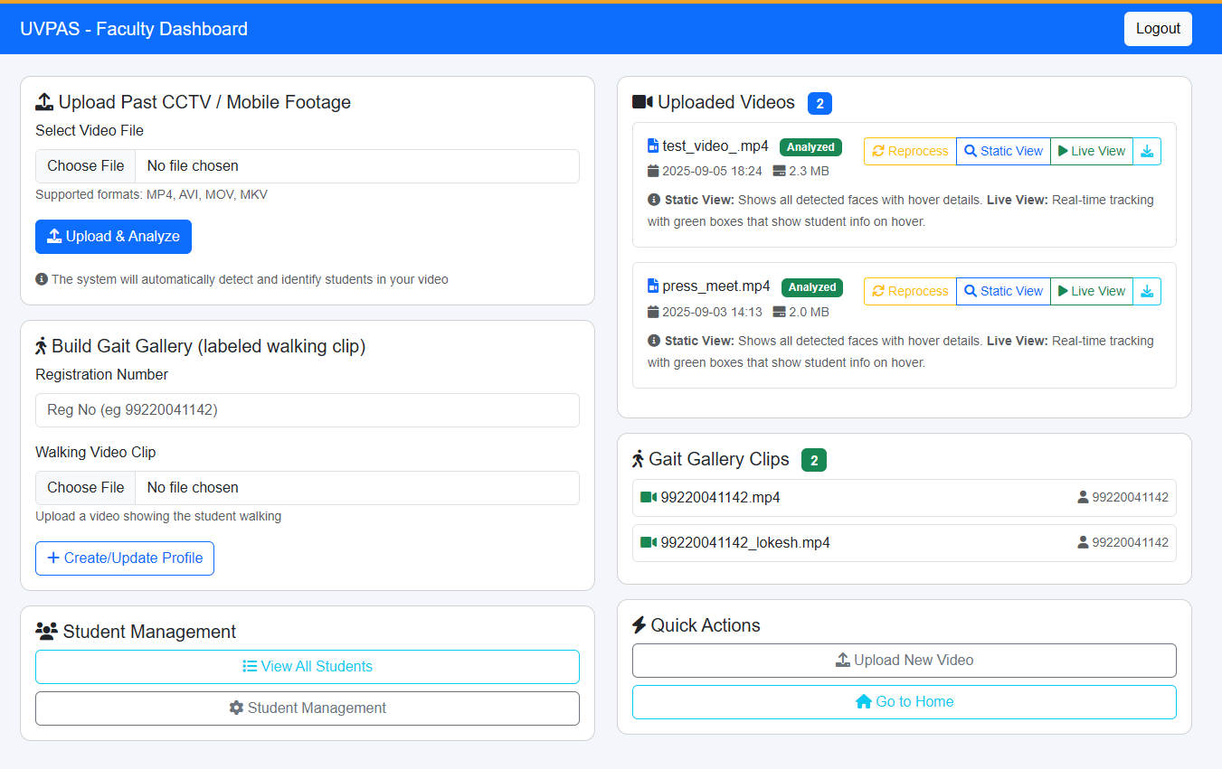

Fig 5.2 Faculty dashboard
Figure 5.3 presents the Video Viewer interface, where uploaded classroom or campus footage is analyzed in real time to identify the presence of students using facial recognition. The system automatically highlights detected faces with green bounding boxes and displays the corresponding registration numbers above each recognized student, while unknown individuals are marked accordingly for further manual verification. The interface includes interactive detection features such as hovering over the bounding box to reveal student details and clicking the registration number to instantly redirect faculty to the respective student profile. Playback controls—including play, pause, replay, loop, mute, and frame refresh—enable faculty to thoroughly inspect the video and review recognition outcomes. Real-time tracking continuously locks onto detected faces across video frames, even during movement, ensuring high accuracy under dynamic recording conditions. Overall, this module provides an intuitive and visual way for faculty to validate attendance and monitor student presence without manual roll call.
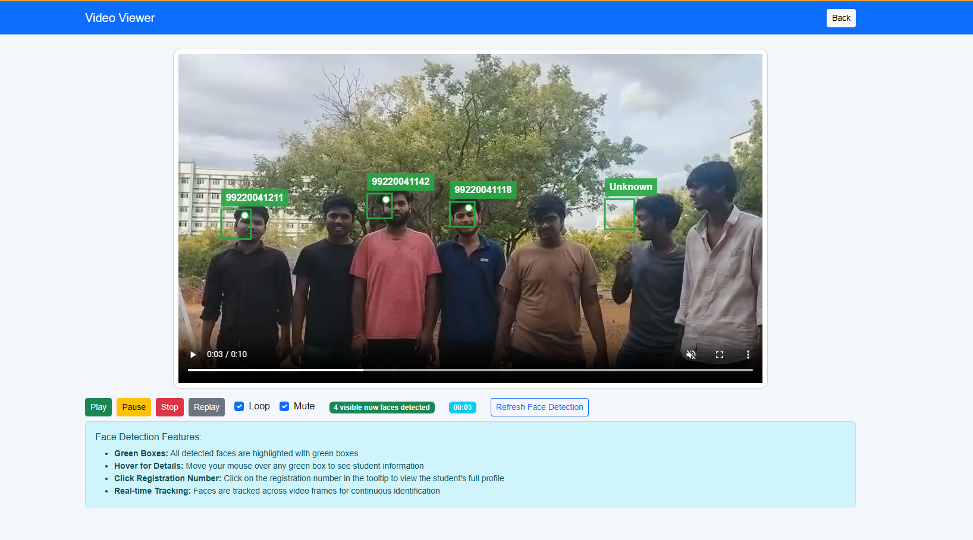
Fig 5.3 Video Analysis
Figure 5.4 presents the Student Report and Analysis Page, which provides faculty with a detailed view of the student’s identity and recognition records in the system. At the top of the page, the student’s name and registration number are prominently displayed, followed by summary indicators showing the number of photos uploaded, the department, and the guardian’s name for quick verification. The section below lists core profile information, including registration number, full name, department, father’s name, and parent contact details, along with a portal link that directs faculty to the student’s external academic profile if available. A dedicated panel titled “Student Photos” allows faculty to review the stored front, left, and right facial images that are used for multi-angle recognition during attendance processing. Navigation buttons at the bottom—“Back to Dashboard” and “View Recent Analysis”—enable users to seamlessly return to the main dashboard or view the most recent video presence detection results. Overall, this interface centralizes student identity and recognition data, supporting fast validation and improved transparency in automated attendance management. 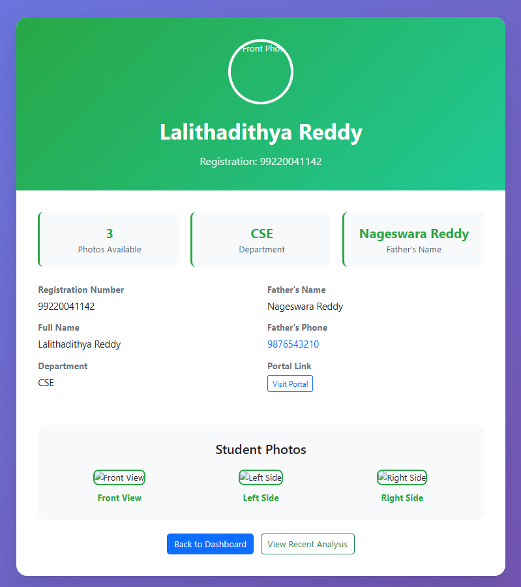

Fig 5.4 Redirection to Student Profile

- RESULT AND DISCUSSION

Figure 6.1 illustrates the processing time distribution across the four major stages of the proposed Video Presence Analysis System: preprocessing, detection, recognition, and matching. Recognition accounts for the highest execution time at 35%, indicating that generating and comparing FaceNet embeddings is the most computationally intensive part of the pipeline. Detection takes 30%, which reflects the high processing cost of running the MTCNN detector frame by frame, especially under varying illumination and motion conditions. Preprocessing contributes 25%, driven mainly by image enhancement operations such as deblurring and resolution correction, which significantly improve downstream recognition accuracy. The remaining 10% corresponds to the matching phase, where extracted feature vectors are compared with stored database embeddings to determine student identity. Overall, the results highlight that although recognition dominates the computation time, the cumulative workflow remains balanced enough to support real-time performance. These findings emphasize the importance of optimizing the recognition and detection stages to further reduce latency without compromising the reliability of face identification in surveillance environments.

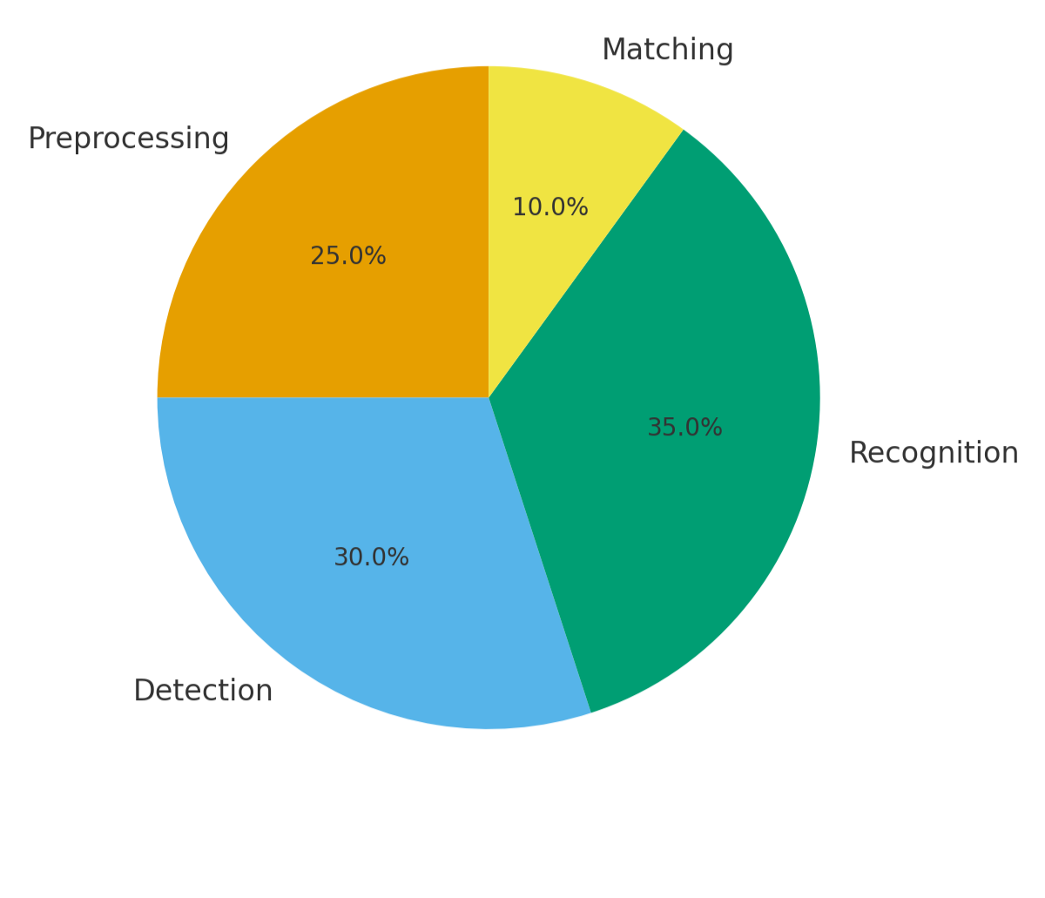
Fig.6.1 – Time and Energy Consumption Breakdown Across System Operations

- CONCLUSION
The development of the University Video Presence Analysis System demonstrates that integrating video enhancement, face recognition, and gait analysis can provide a reliable and scalable solution for student identification in surveillance environments. The system effectively addresses challenges associated with low-resolution footage, motion blur, and partial occlusions by combining preprocessing with advanced recognition techniques. The inclusion of a web-based interface ensures practical usability by allowing faculty to access student profiles directly and review unmatched cases when necessary. The achieved accuracy of over 90% highlights the robustness of the proposed approach, making it suitable for large-scale deployment in universities where monitoring and verification are essential. Future work will focus on improving the scalability and privacy of the system through techniques such as federated learning, which enables collaborative model training without centralized data sharing. Additionally, the integration of adversarial training is
planned to strengthen resistance against spoofing or manipulation attempts, ensuring long-term reliability in real-world deployments.
8 REFERENCES

- Alhanaee, K., et al. (2021). Smart Attendance Tracking Using Convolutional Neural Networks and Deep Learning Techniques.
- Bugingo, E., et al. (2025). Improving Attendance Management through Face Recognition with Real-Time Facial Tracking.
- Sharma, P., & Sahu, A. (2022). Intelligent Attendance Management System Using Face Recognition and Machine Learning.
- DG HL, et al. (2020). Face Recognition based Attendance System.
- Wanjare, S. B., Mahajan, J. R., & Gadekar, S. S. (2024). Contactless Smart Attendance System Using Facial Recognition and QR Code.
- Li, H., et al. (2022Real-Time Student Attendance Monitoring Using Face Recognition with CNN and MTCNN.Procedia Computer Science, 199, 428–435.
- Mehmood, R., & Ullah, H. (2023). Smart Attendance Monitoring System Using Face Recognition with Liveness Verification. Sensors, 23(3), 1125.
- Rao, A. (2022). AttenFace: A Real-Time Student Attendance Management System Using Facial Recognition.
- Saraswat, D., et al. (2023). Contactless Attendance Monitoring System with Anti-Spoofing Mechanisms.
- Dixit, H. V. (2024). Automated Attendance System Using Face Recognition.
- Kulkarni, S. (2023). Attendance Monitoring System using Face Recognition.
- Budiman, A., et al. (2023). Student Attendance System Using Face Recognition with LBPH and CNN Techniques.
- Smart Attendance System: Using Facial Recognition Technology. (2024).
- Masutage, A. A., Raynade, S. C., Patil, P. B., et al. (2023). Facial Recognition Attendance System (FRAS) based on Image Processing.

